8.4
FIFO
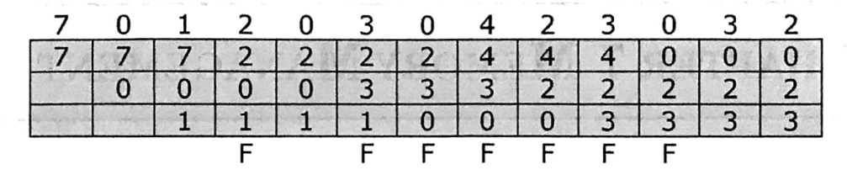
LRU
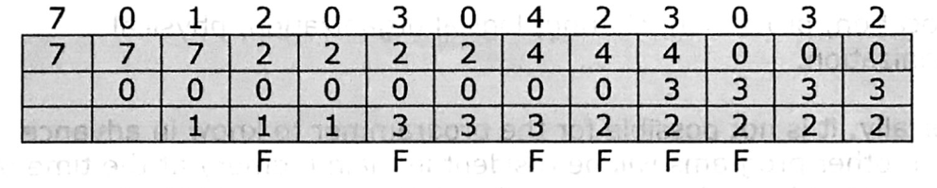
Clock
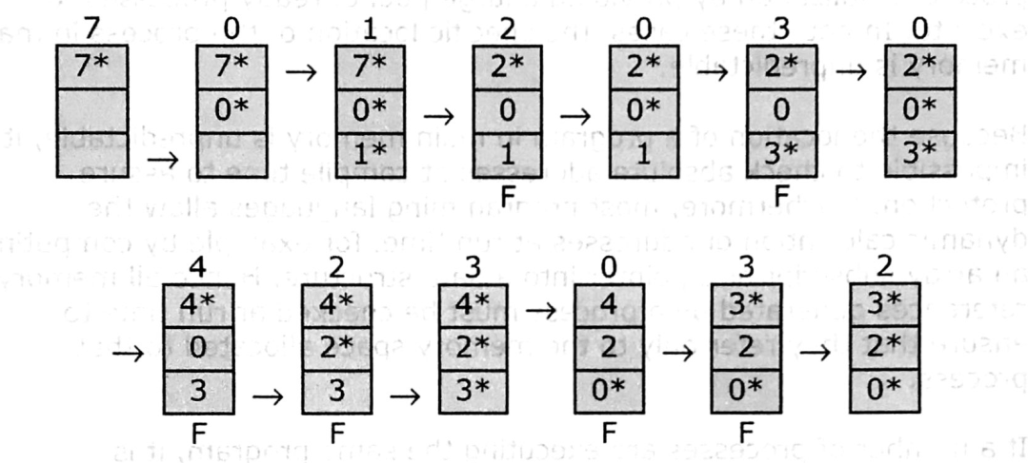
OPT
